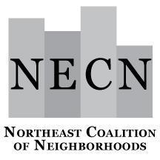

NECN Board of Directors Meeting
Tuesday, December 19, 2023
6:30 – 8:00 p.m.
Zoom Link

Agenda
6:30 p.m. Welcome, Introductions (Jimmy and Sean)
Review Agenda
Approve Board Minutes

6:45 p.m. Acknowledge Neighborhood Representatives (Jimmy and Sean)
- Board Member Required Documents
- Confirm Neighborhood Representatives (if any new)
- Open Parliamentarian Officer Position

7:00 p.m. Bylaws (Jona)
- Bylaws
  - Document with proposed changes
  - Work session?

7:15 p.m. Budget Update

7:30 p.m. Small Grants Report
- Vote to accept recommendations

7:45 p.m. Organization Planning through June 2024

- Requested Presentations/Speakers
- Trainings:
  - NECN Board Members: Rolls/Requirements/DEI
  - Neighborhood Board Member

7:50 p.m. Neighborhood Updates/Announcements (Everyone)
- Send events to NECN so it can be published in the NECN newsletters

7:55 p.m. Confirm NECN Meeting Dates for 2024 (Everyone)
8:00 p.m. Meeting Adjourn

Next Meeting: Tuesday, January 16, at 6:30 p.m.

