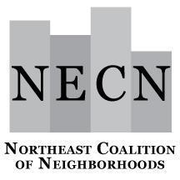

NECN Board of Directors Meeting
Tuesday, November 21, 2023
6:30 – 8:00 p.m.
Zoom Link

Agenda

6:30 p.m. Welcome and Introductions (Jimmy and Sean)

Review Agenda
Consent Agenda:
- 2023 Minutes for revision or approval

6:40 p.m. Executive Director Updates (Jona)
City of Portland Organizational Restructuring

6:50 p.m. 2023-24 Budget/Bylaws Discussion (Jona)
Acknowledge changes in expenses
Potential purchase of a meeting Owl: info abo/video about meeting OWLs

7:05 p.m. Create a Bylaws task force to explore possible revisions (Board)

7:10 p.m. Acknowledge Neighborhood Representatives (Jimmy and Sean)

7:20 p.m. Revisiting/Confirm/Elect/Executive Officers (Board)
7:40 p.m. Neighborhood Updates/Announcements (Everyone)
(Newsletters, updates, block party invitations, etc.)

7:50 p.m. Confirm NECN Meeting/Training Dates for 2023/24 (Board)

8:00 p.m. Meeting Adjourn

Next Meeting: Tuesday, December 19, at 6:30 p.m.
(To be confirmed - Holiday week)

